Part 7 ADSL Broadband Account Activation

After Chunghwa Telecom technicians have finished installing your ADSL network line, the first time you connect you can only go to the So-net Website http://www.so-net.net.tw. Please go to the ADSL broadband account activation web page http://www.so-net.net.tw/service/member/activate_adsl.html. If you already received So-net User Manuel, please click the left icon. On the contrary, click the right icon. Here we demo the first situation.
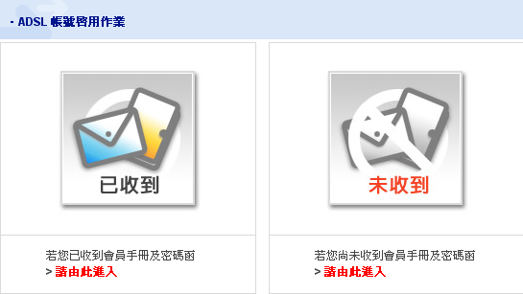

So-net reminds you that when your ADSL line is fully installed you should register with the ADSL Installation date, user name, password and ADSL broadband account activation code we sent you in your code letter. Enter your details to register then remember to disconnect and reconnect your So-net ADSL. After entering your user name and password, you can use So-net ADSL broadband services.
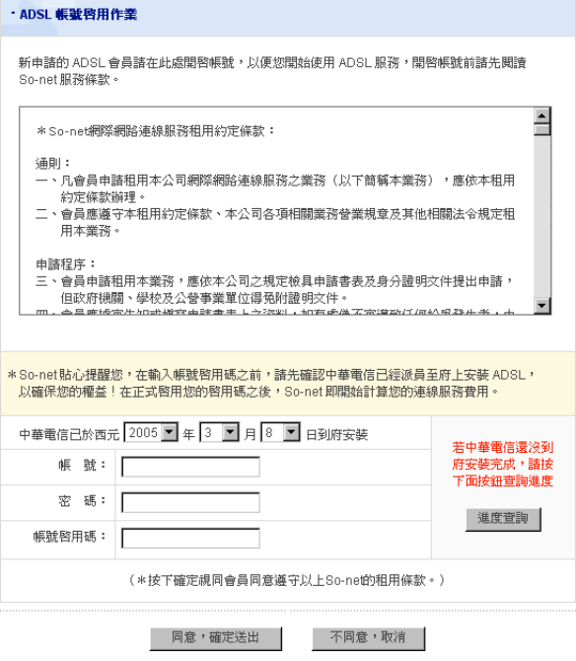
User Name
Password
Activation Code

ADSL Installation date

