Part 6 Fixed IP ADSL Network Component Settings
(for Win 98)
Once your network adapter is installed, you have to set your network component settings before you can go online and make use of high-speed ADSL. If you applied for fixed IP ADSL, please look at the network component settings steps below (fixed IP ADSL does not require PPPoE installation). To take users of different systems into account, we have provided separate network component settings explanations for Windows 98, Windows ME, Windows NT, Windows 2000 and Windows XP.

- Windows 98 English Version – Fixed IP ADSL Connection Settings

1. Right click on the [Network Neighborhood] icon on your desktop and select [Properties]. | 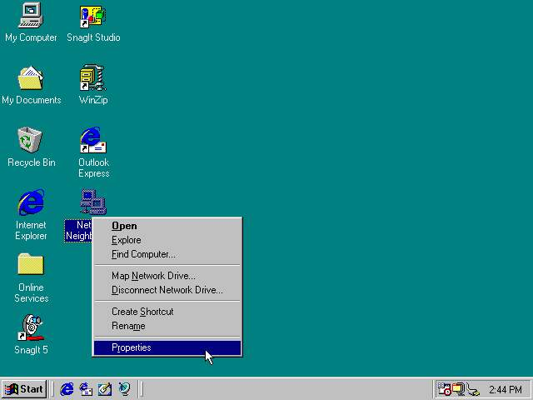
2. Under the [Configuration] tab, select [TCP/IP -> (your adapter)] and click [Properties]. | 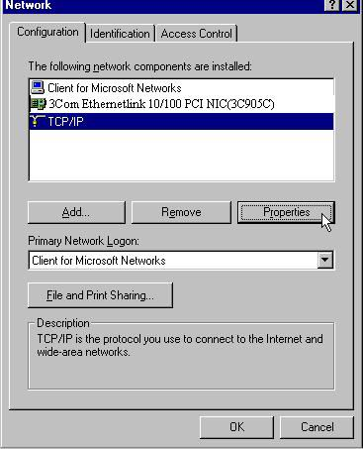
3. On the [IP Address] tab, select [Specify an IP address] and enter the [IP Address] and [Subnet Mask]. For these figures, refer to the documentation supplied by So-net. | 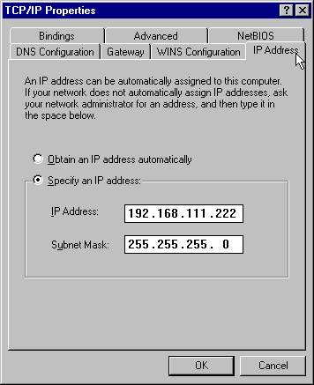
4. Select the [Gateway] tab. Enter the [New gateway] and remember to press [Add]. For the Gateway figure, refer to the documentation supplied by So-net. | 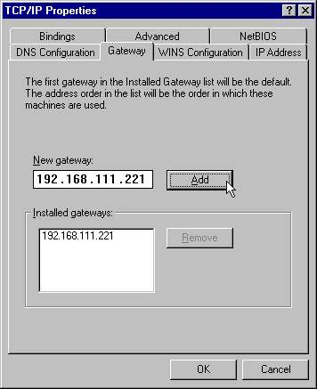
5. Select the [DNS Configuration] tab. Select [Enable DNS] and type whichever [Host] name you like. Beneath [DNS Server Search Order] enter the DNS server address. For this address, refer to the documentation supplied by So-net. Remember to press [Add] when you have entered the address, then press [OK]. | 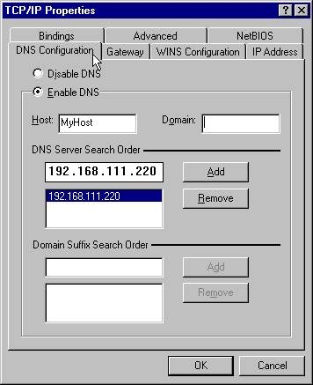
6. Return to the [Configuration] tab and click [OK] to complete the setup. | 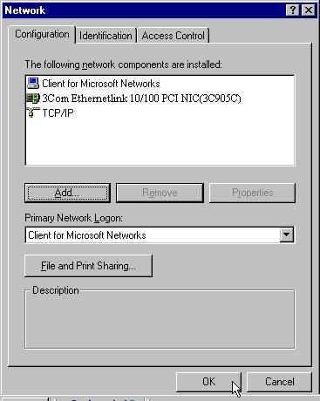
7.When asked if you want to restart your computer, click [Yes]. | 