Part 5 ADSL PPPoE Connection Software Installation and Setup (for Variable IP ADSL)

When the hardware setup has been completed to this point, you can start to make use of your ADSL broadband Internet services. The So-net member services CD-ROM cannot be used on English edition operating systems, so please go first to the So-net web site to download ADSL PPPoE connection software (http://www.so-net.net.tw/service/download/dial.html). Save it on your computer. Windows XP users should use the connection program provided with Windows XP and do not need to download the software.

1. Open the contents of the downloaded file at the location you downloaded it to (in this example E:\PPPoE). | 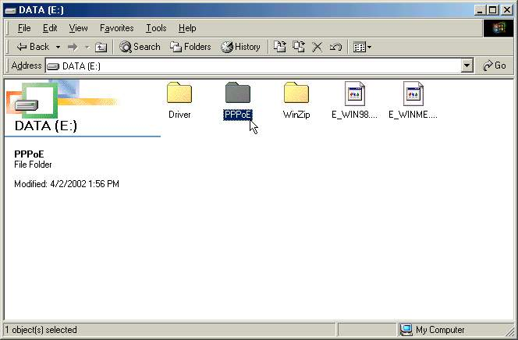
2. Double click on the [setup.exe] icon to begin installation. | 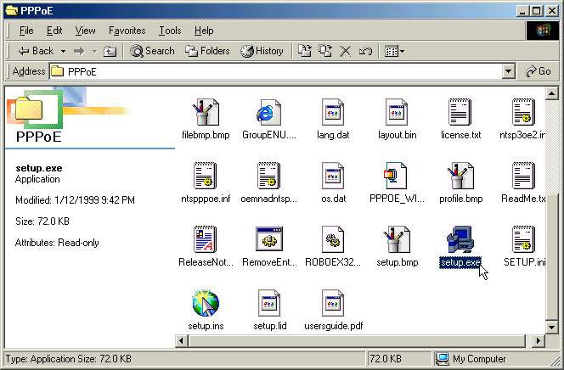
3. Select an installation type: We suggest you choose [Quick Install (accept default settings)]. Your system will install the components automatically. Click [Next]. | 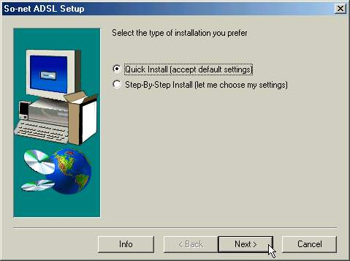
4. When the files have been copied, we suggest you select [Yes, I want to restart my computer now] and then click [Finish] to finish the installation | 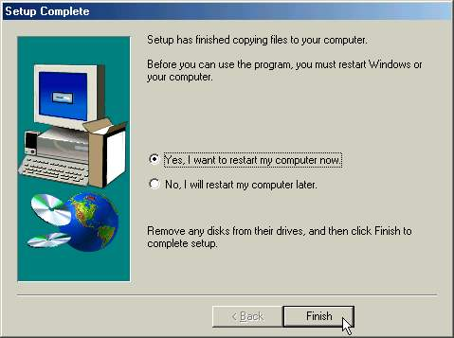
5. When your computer has restarted, a [So-net ADSL] icon will appear on your desktop. Double-click the icon to launch it. | 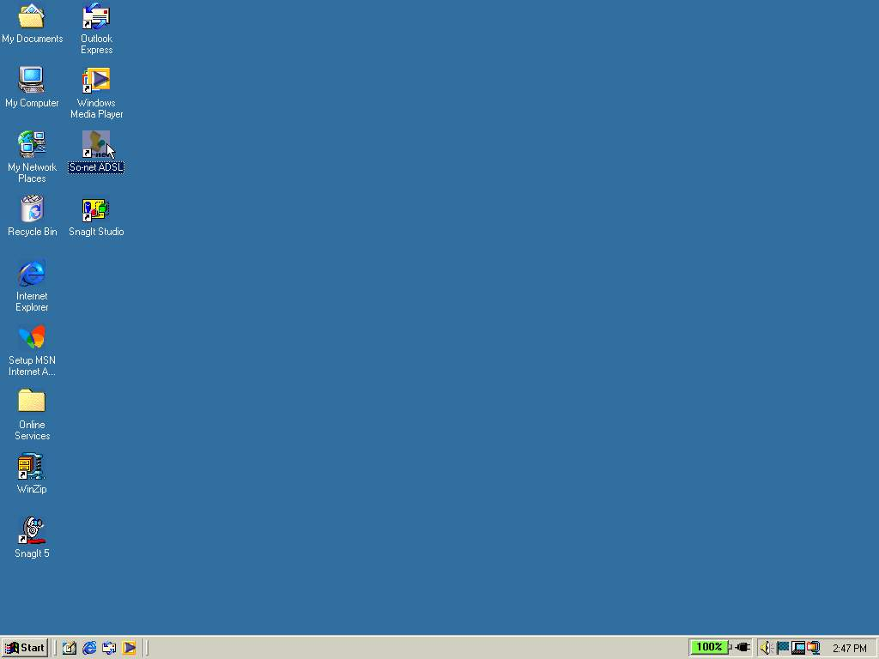
6. You next have to set up a [So-net ADSL] connection. Double-click on the [So-net ADSL] icon. | 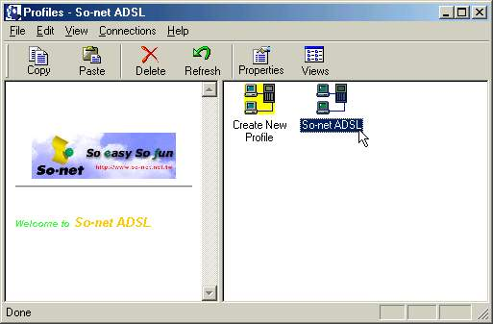
7. Type in the User Name and Password we sent to you in your code letter. Click [Next] to continue. | 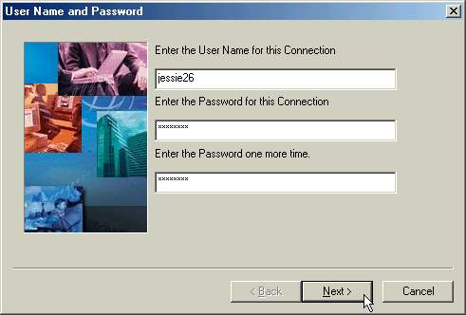
8. You have successfully established the [So-net ADSL] connection. Click [Finish]. | 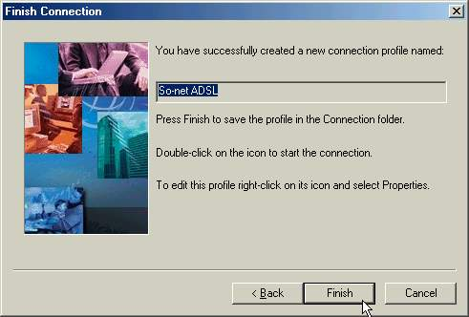
9. A [So-net ADSL] picture will appear on the desktop. Your user name and password have been set. If you want to go online, click [Connect]. | 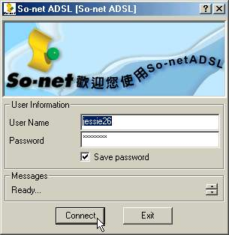
10.When your Username and Password have been verified, the first time you connect you can only go to the So-net Website http://www.so-net.net.tw. Please go to the ADSL broadband account activation web page http://www.so-net.net.tw/service/member/activate_adsl.html. If you already received So-net User Manuel, please click the left icon. On the contrary, click the right icon. Here we demo the first situation. | 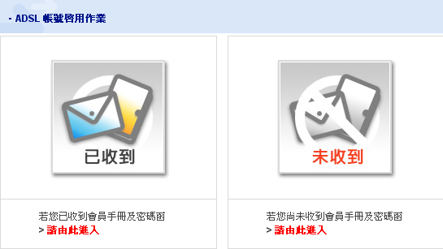
11. Since your computer has an English operating system, the characters may be scrambled on the screen. This is not a problem: When online you can download traditional Chinese character encoding (to do this: select the [View] menu in Internet Explorer, from the [View] menu choose [Encoding]→[More]→[Chinese Traditional] then you can start downloading). | 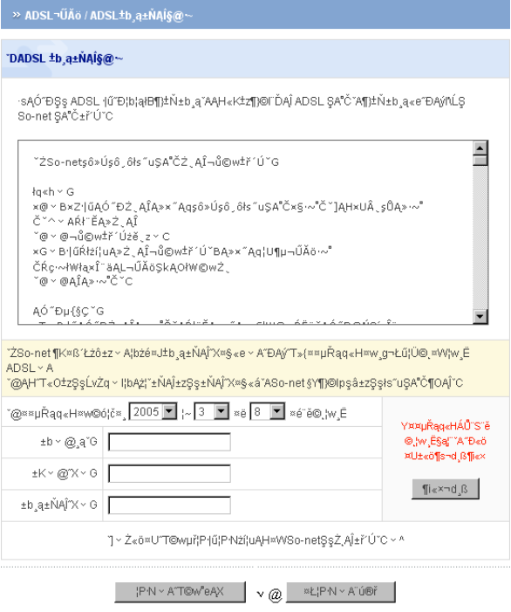
12. The account activation page should look like this. So-net reminds you that you should only enter your ADSL Installation date, user name, password and ADSL broadband account activation code when your ADSL line is fully installed. Enter your details to register then remember to disconnect and reconnect. | 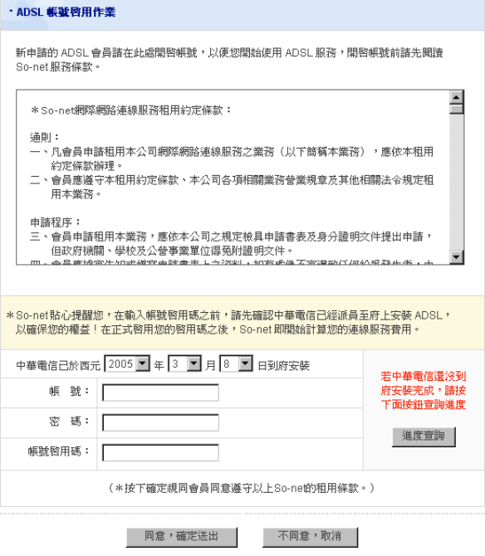  ADSL Installation  User Name  Activation Code  Password
13. To reconnect, double-click on the [So-net ADSL] icon on the desktop. When connected, you can start using all So-net ADSL broadband services. | 
14. To check ADSL connection settings, right-click on the connection icon and select [Properties]. | 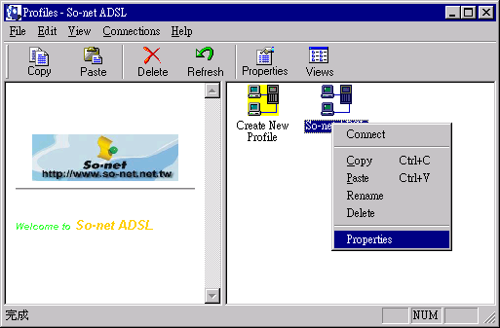
15. Check that the [User Name] and [Password] on the [User Information] tab are correct. | 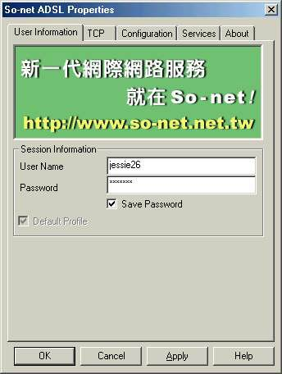
16. Select the [TCP] tab and select and check the [Server Assigned IP Address], [Server assigned DNS/NBNS server addresses] and [Use default gateway on remote network] boxes. Then click [OK]. | 