Part 4 Variable IP ADSL Network Component Settings
(for Win XP)
Once your network adapter is installed, you have to set your network component settings before you can go online and make use of high-speed ADSL. If you applied for variable IP ADSL, please look at the network component settings steps below and install PPPoE. To take users of different systems into account, we have provided separate network component settings explanations for Windows 98, Windows ME, Windows NT, Windows 2000 and Windows XP.

- Windows XP English Version – ADSL Connection Settings

Please use the PPPoE provided with Windows XP to go online. There is no need to install the PPPoE software provided on the So-net member services disk.
1. Click on the [Start] button at the bottom left corner of your desktop with your left mouse button. When the Start menu appears, select [Control Panel]. | 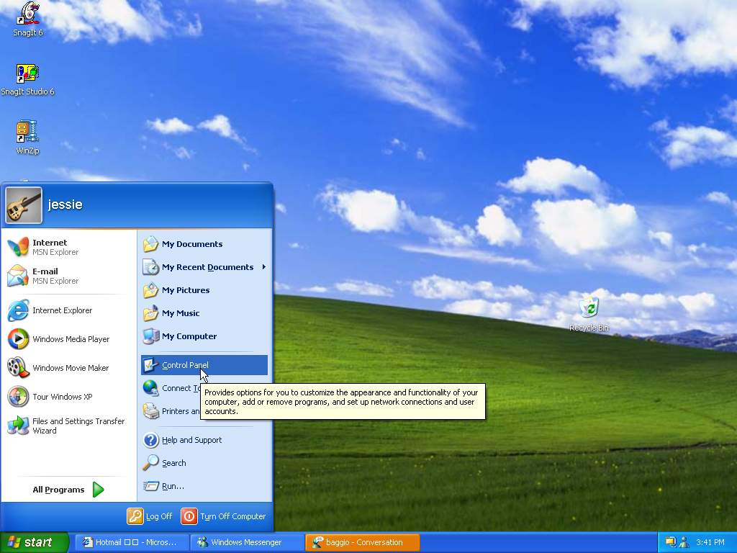
2. In the [Control Panel] window, click [Network and Internet Connections]. | 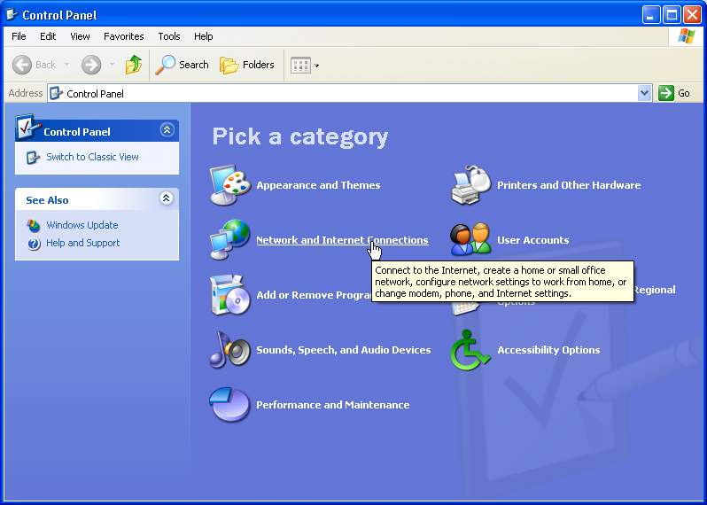
3. In the [Network and Internet Connections] window, choose [Network Connections]. | 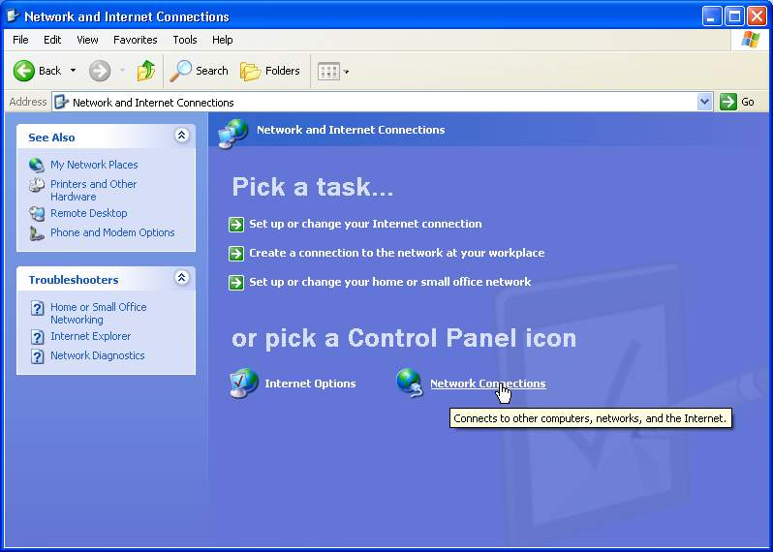
4. In the [Network Connections] window, select [Create New Connection]. | 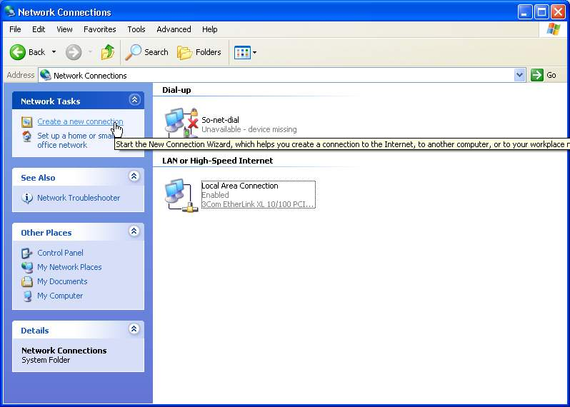
5. When the [New Connection Wizard] appears, click [Next] to continue. | 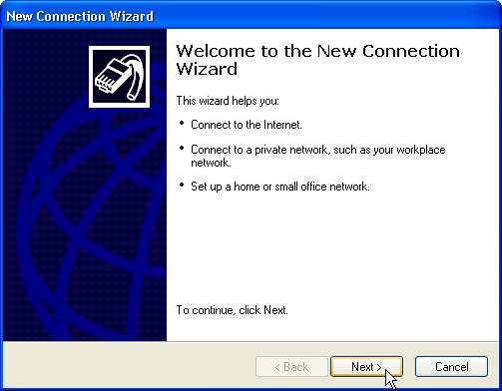
6. Select [Connect to the Internet] as your connection type. Click [Next]. | 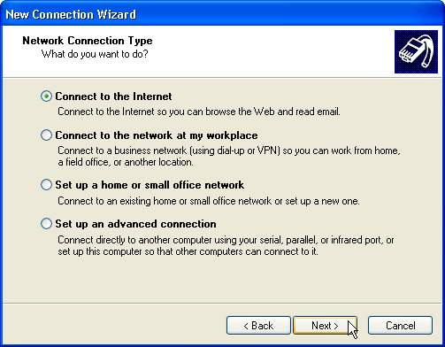
7. Select [Set up my connection manually] and click [Next]. | 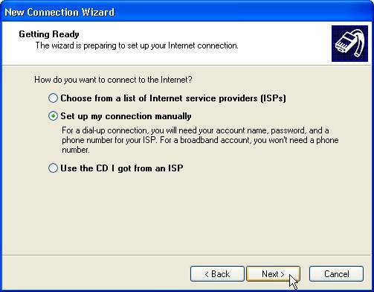
8.Select [Connect using a broadband connection that requires a user name and password] and click [Next]. | 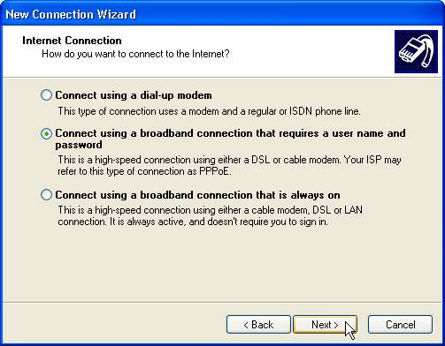
9. Enter the connection name [So-net] then click [Next]. | 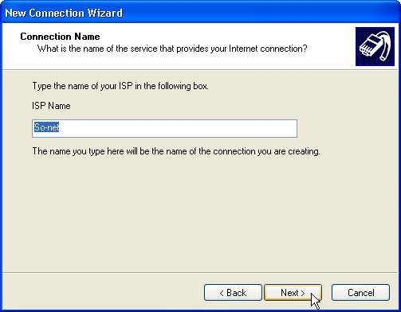
10. Enter the Account ID (User name) and Password (twice) applied for from So-net. Make sure there are no mistakes, then click [Next]. | 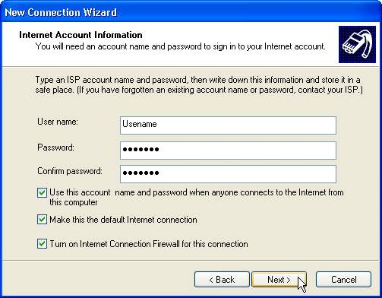
11. Finally, check the [Add a shortcut to this connection to my desktop] box and click [Finish] to finish the PPPoE broadband connection setup process. | 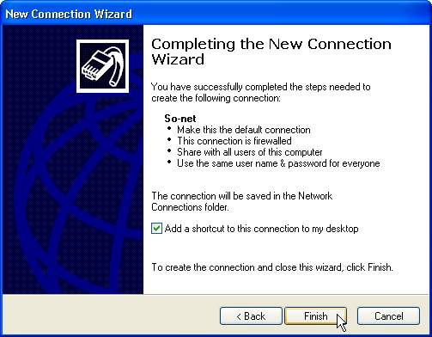
12 When the setup is complete, a So-net icon will appear on your desktop and under the [Network Connections] section of the Control Panel. If you want to make a dial-up connection, just double click with the left mouse button on either icon. | 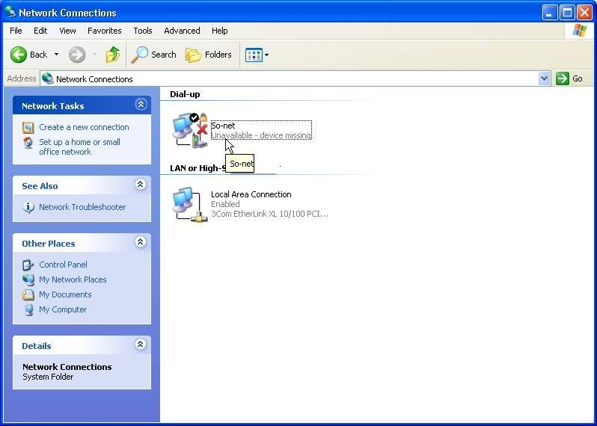
13. The connection window will then appear. Click [Connect] to go online. | 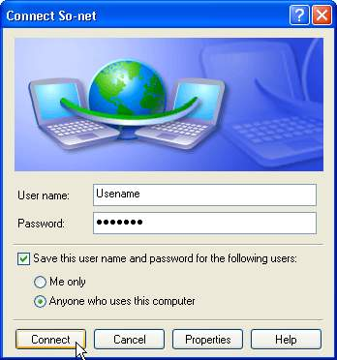
14.When your Username and Password have been verified, the first time you connect you can only go to the So-net Website http://www.so-net.net.tw. Please go to the ADSL broadband account activation web page http://www.so-net.net.tw/service/member/activate_adsl.html. If you already received So-net User Manuel, please click the left icon. On the contrary, click the right icon. Here we demo the first situation. | 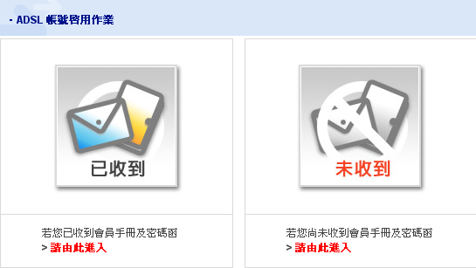
15. So-net reminds you that you should only enter your ADSL Installation date, user name, password and ADSL broadband account activation code when your ADSL line is fully installed. Enter your details to register then remember to disconnect and reconnect. | 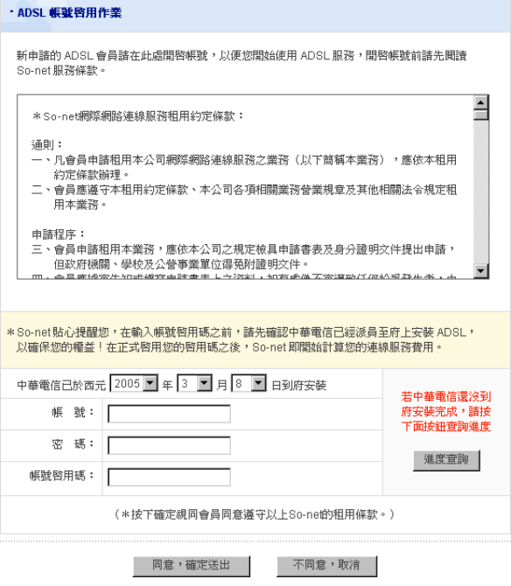  ADSL Installation  User Name  Activation Code  Password
16. To reconnect, double-click on the on the [So-net] icon on the desktop. When the connection window appears, click [Connect] then you can start using all So-net ADSL broadband services. | 

