Part 4 Variable IP ADSL Network Component Settings
(for Win ME)
Once your network adapter is installed, you have to set your network component settings before you can go online and make use of high-speed ADSL. If you applied for variable IP ADSL, please look at the network component settings steps below and install PPPoE. To take users of different systems into account, we have provided separate network component settings explanations for Windows 98, Windows ME, Windows NT, Windows 2000 and Windows XP.

- Windows ME English Version – ADSL Network Components Settings

1. Right click on the [My Network Place] icon on your desktop and select [Properties]. | 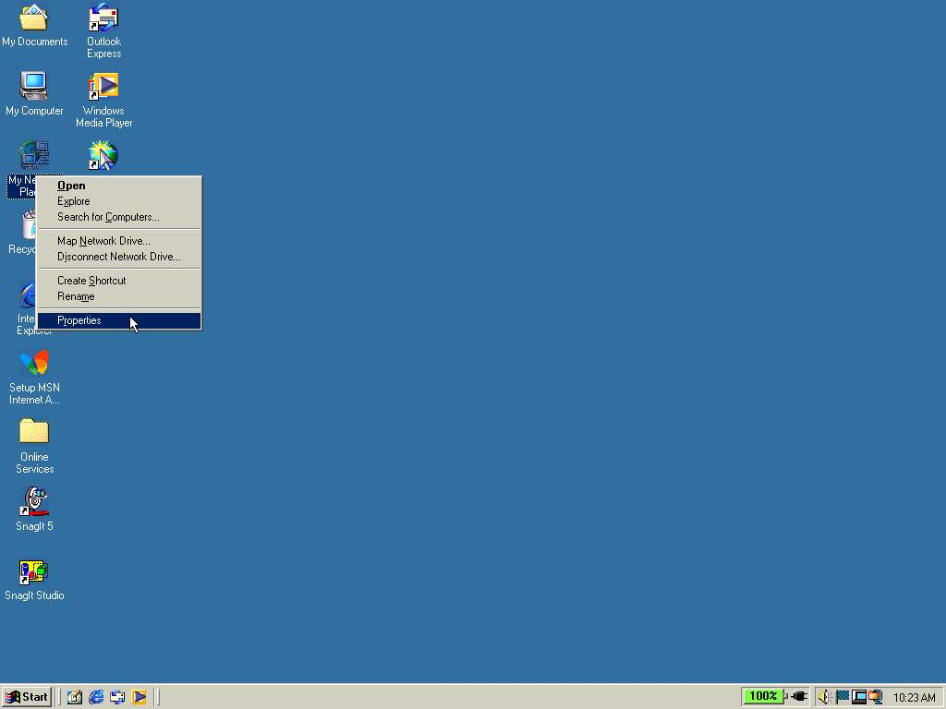
2. Under the [Configuration] tab, select the [TCP/IP] component. Click [Properties]. | 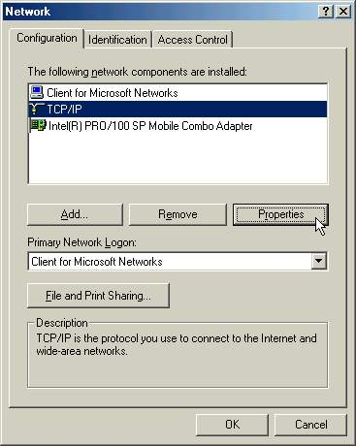
3. On the [IP Address] tab select [Obtain an IP address automatically] and click [OK]. | 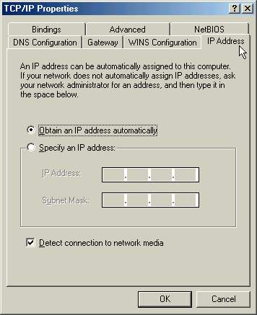
4. Click [OK] again. | 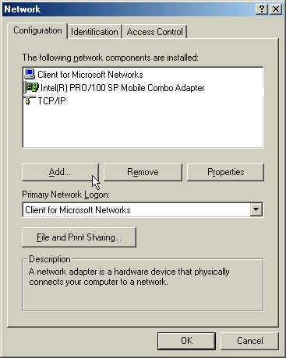
5. Click [Yes] when asked if you want to restart your computer to complete the process. | 