Part 4 Variable IP ADSL Network Component Settings
(for Win 98)
Once your network adapter is installed, you have to set your network component settings before you can go online and make use of high-speed ADSL. If you applied for variable IP ADSL, please look at the network component settings steps below and install PPPoE. To take users of different systems into account, we have provided separate network component settings explanations for Windows 98, Windows ME, Windows NT, Windows 2000 and Windows XP.

- Windows 98 English Version –ADSL Network Components Settings

1. Right click on the [Network Neighborhood] icon on your desktop and select [Properties]. | 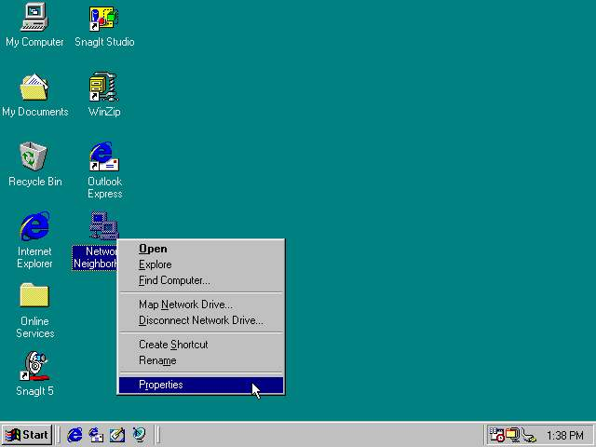
2. Check that [TCP/IP] is showing in the network component box under the [Configuration] tab. If not showing, click [Add]. If present, go to step 5. | 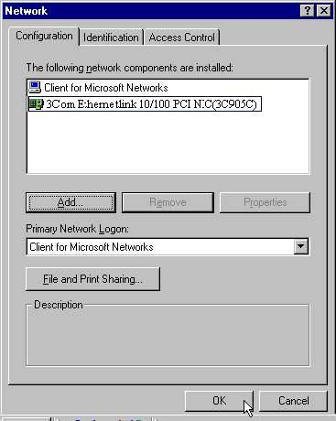
3. Select [Protocol], then click [Add…]. | 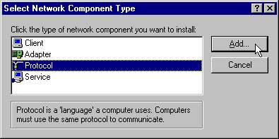
4. In the Manufacturers box on the left, select [Microsoft]; in the Network Protocols box on the right, select [TCP/IP]. Click [OK]. | 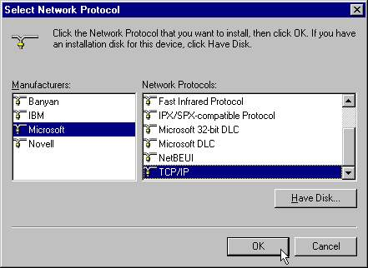
5. TCP/IP should now be visible on the [Configuration] tab. Select [TCP/IP] then click [Properties]. | 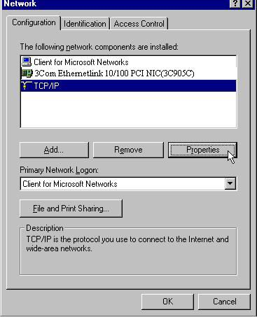
6. On the [IP Address] tab select [Obtain an IP address automatically] and click [OK]. | 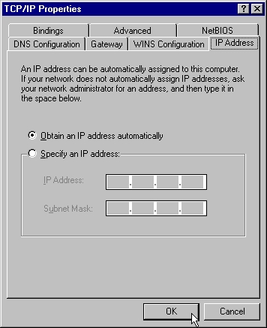
7. On the [Configuration] tab click [OK] to complete the setup process. | 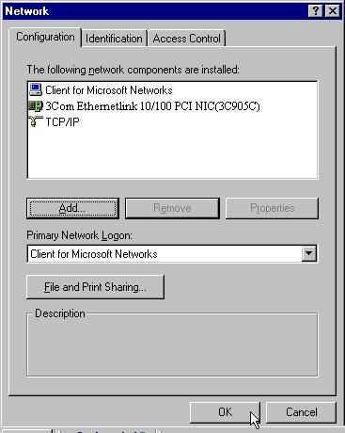
8. Click [Yes] to restart your computer. | 