Part 4 Variable IP ADSL Network Component Settings
(for Win 2000)
Once your network adapter is installed, you have to set your network component settings before you can go online and make use of high-speed ADSL. If you applied for variable IP ADSL, please look at the network component settings steps below and install PPPoE. To take users of different systems into account, we have provided separate network component settings explanations for Windows 98, Windows ME, Windows NT, Windows 2000 and Windows XP.

- Windows 2000 English Version – ADSL Network Components Settings

1. Click on the [Start] button at the bottom left corner of your desktop with your left mouse button. When the Start menu appears, select [Settings] and then click on [Control Panel]. | 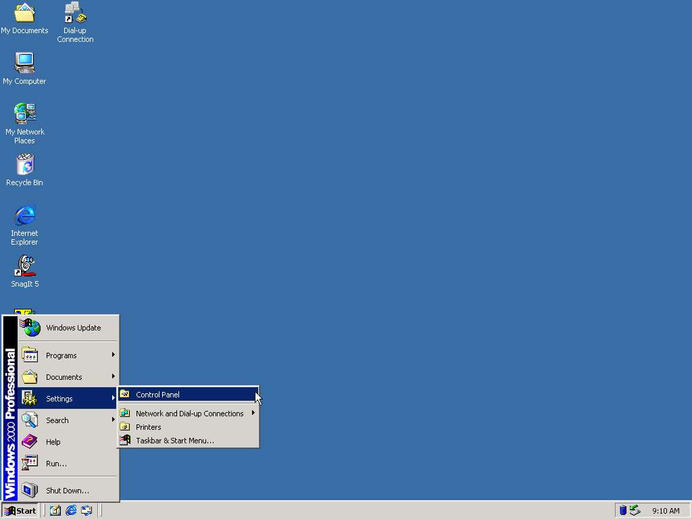
2 Double-click on the [Network and Dial-up Connections] icon in the Control Panel window. | 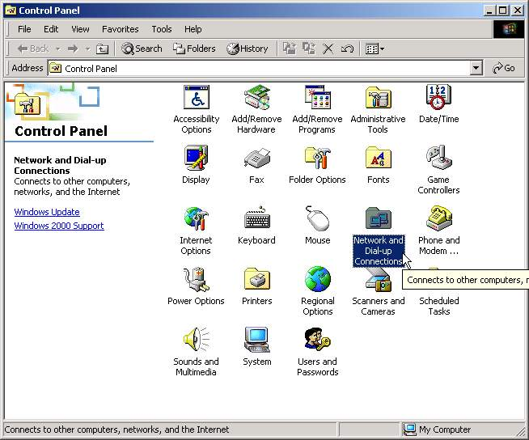
3. Click the [Make New Connection] icon. | 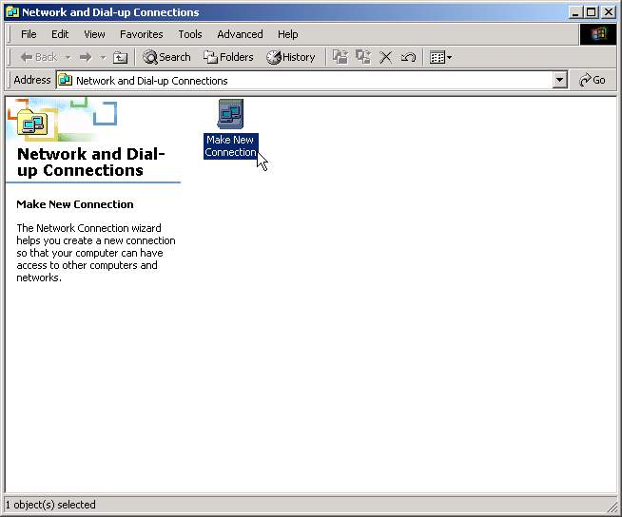
4. When the [Network Connection Wizard] appears, click [Next] to continue. | 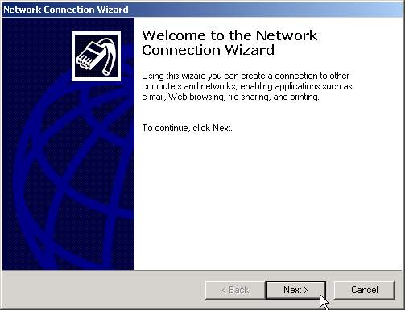
5. Select [Dial-up to the Internet] and click [Next]. | 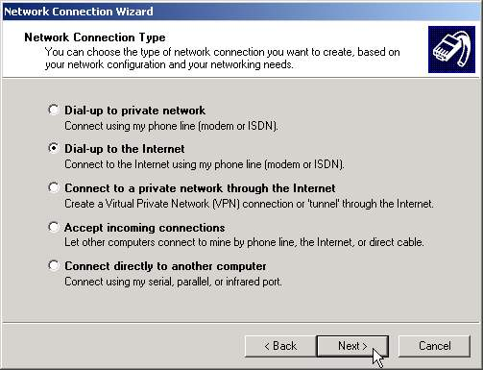
6. After selecting [I want to set up my Internet connection manually], press [Next]. | 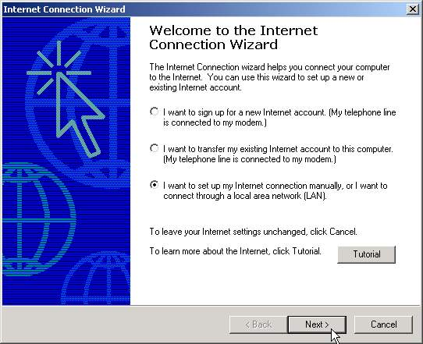
7. Select [I connect through a local area network (LAN)], then press [Next]. | 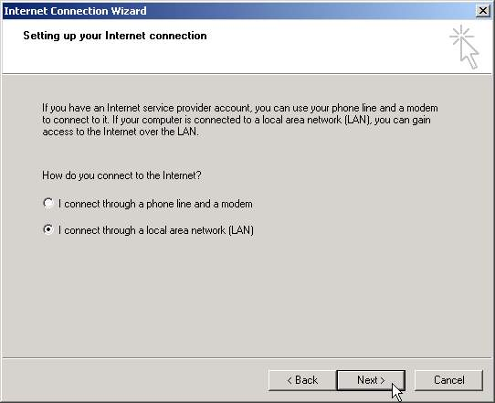
8. Do not check the [Automatic discovery of proxy server (recommended)] box. Click [Next]. | 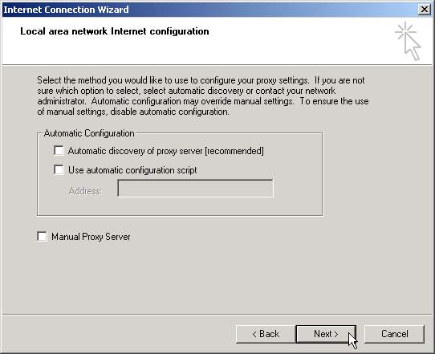
9. When the [Set up Your Mail Account] window appears, we recommend you wait a while before setting up an email account, Select [No], then [Next]. | 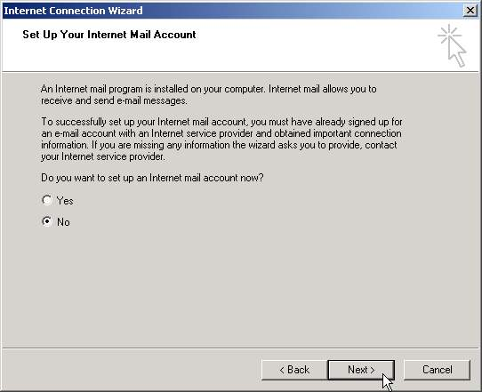
10. Click [Finish]. | 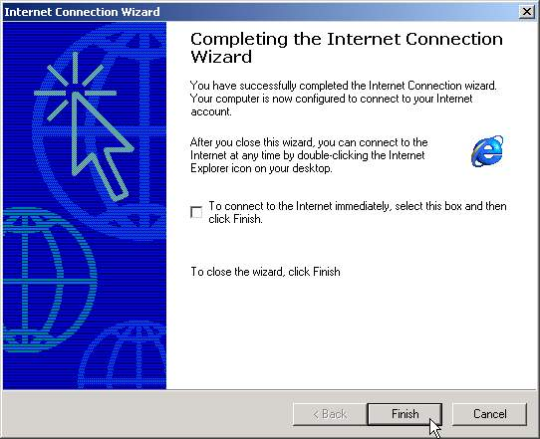
11.After completing the setup, right-click on the [Local Internet] icon in [Network and Dial-Up Connections]. Select [Properties]. | 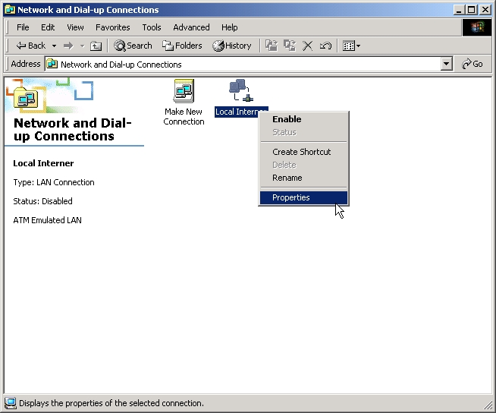
12. Select [Internet Protocol (TCP/IP)] then enter [Properties]. | 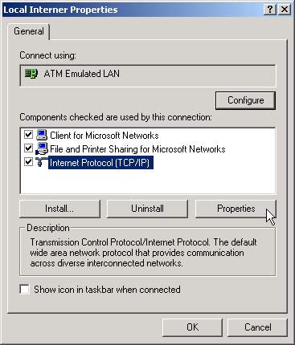
13.Select both [Obtain an IP address automatically] and [Obtain DNS server address automatically] and click [OK] to complete the setup. | 