Part 3 Installing the Network Adapter (for Win ME)
  - Choosing a network adapter
There are many brands of network adapter that fit different interfaces, manufacturers and operating systems and their installation procedures differ. If the network adapter installation procedures below do not fit your system, please refer to the installation instruction provided with your network adapter.
  - Installing a network adapter
We shall outline the steps for installation with Windows 98, Windows ME, Windows NT and Windows 2000.

- Windows ME English Version –ADSL Network Adapter Checking

Since Windows ME supports your network adapter, there is no need for a driver disk. First turn off your computer, insert the network adapter and restart the computer. The system will automatically find and install the network adapter driver program. You only need to check that the network adapter has been correctly installed when the installation is complete.
1. Right click on the [My Network Place] icon on your desktop and select [Properties]. | 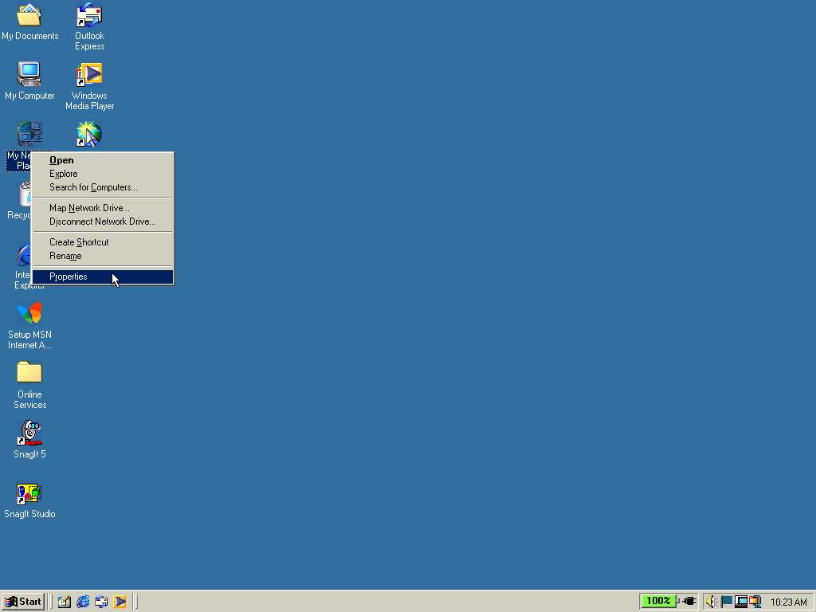
2. Under the [Configuration] tab check that your network adapter is displayed. Then click [OK]. | 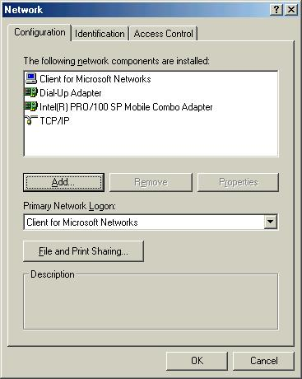
3. Next you should check whether the network adapter is functioning. Right click on the [My Computer] icon on your desktop and select [Properties]. | 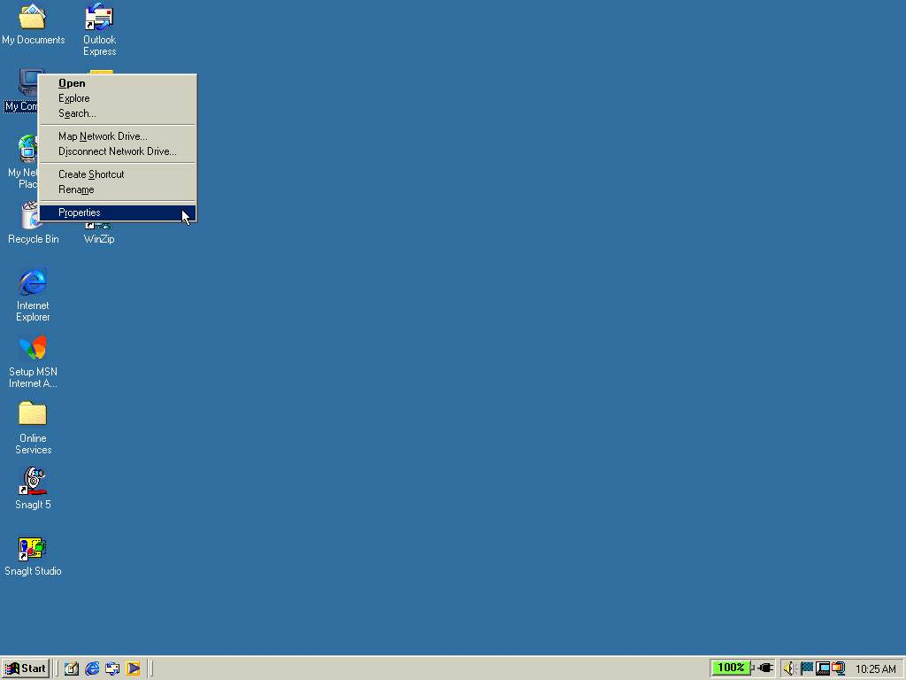
4. Select the [Device Manager] tab and click on [Network adapters]. If your network adapter does not have an exclamation mark or question mark next to its name, then the card is OK. Click [OK] to leave. | 