Part 3 Installing the Network Adapter (for Win 2000)
  - Choosing a network adapter
There are many brands of network adapter that fit different interfaces, manufacturers and operating systems and their installation procedures differ. If the network adapter installation procedures below do not fit your system, please refer to the installation instruction provided with your network adapter.
  - Installing a network adapter
We shall outline the steps for installation with Windows 98, Windows ME, Windows NT and Windows 2000.
First turn off your computer and insert the network adapter, then restart your computer.

- Windows 2000 English Version – ADSL Network Adapter Checking

Windows 2000 supports network adapters and the system will automatically find and install a driver. You only need to check that the network adapter has been correctly installed.
1. Click on the [Start] button at the bottom left corner of your desktop with your left mouse button. When the Start menu appears, select [Settings] and then click on [Control Panel]. | 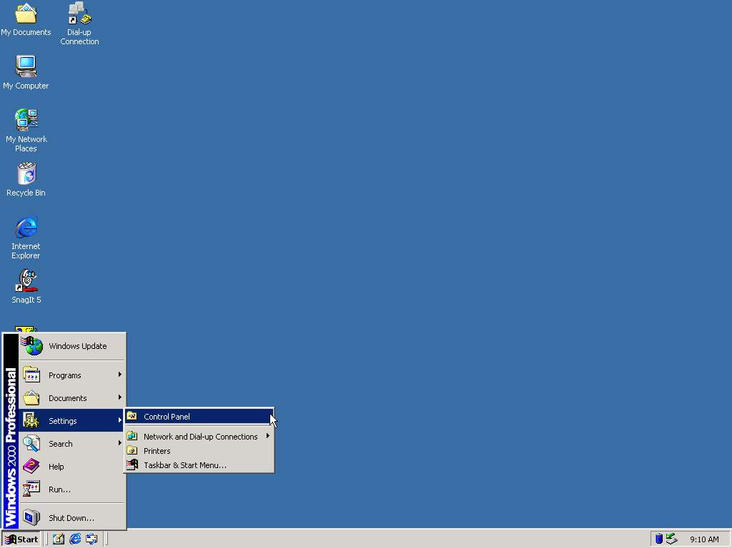
2. Double-click on the [System] icon in the Control Panel window. | 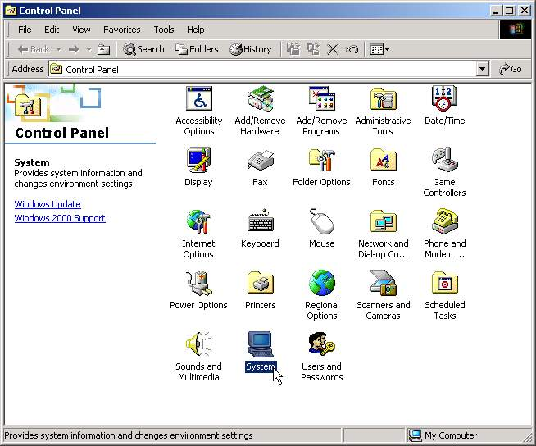
3. In the [System Properties] window select the [Hardware] tab and click [Device Manager]. | 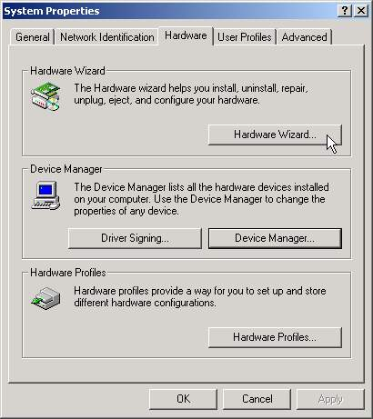
4. Under the [Device Manager] tab click on [Network adapters] to check if your network adapter is installed correctly. If your network adapter does not have an exclamation mark or question mark next to it, then the card is OK. | 