Part 2 ADSL installation
- Diagram of installation procedures:

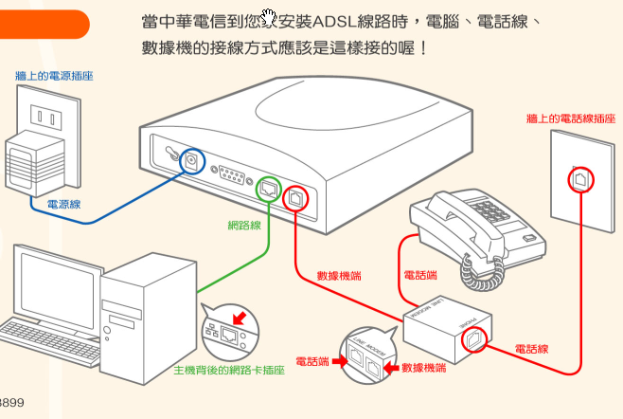
Power
Network line

ADSL Modem

PC
To Tel
Splitter
Tel line
External Tel line
To Modem
Network adapter socket
Outlet

- ADSL Circuits Installation
Chunghwa Telecom technicians will contact you to arrange a convenient time before arriving to install your ADSL modem. During the installation, the technician should check the line and open the So-net ADSL new account user web page for you to look at. You should only sign the technician’s form saying work is complete when you are certain there are no connection problems. To protect your rights, you should only sign after confirming the technician has completed the installation according to standard procedures.

- Introduction to the ADSL modem (ATU-R) and its indicator LEDs
The ADSL ATU-R installed by Chunghwa Telecom is available in several brands and the indicators are different on each. Most have at least three LEDs: power, LAN or network adapter signal and ADSL signal. If power is on, the power LED should light constantly. When not connected, the LAN LED and ADSL LED should also be lit constantly. If you attempt a connection or if you are already connected and transmitting data, both of these LEDs will blink. This is the standard setup and you can use it to tell whether the line has been installed correctly.

Example unit: the Speed Touch340 (ALCATEL)
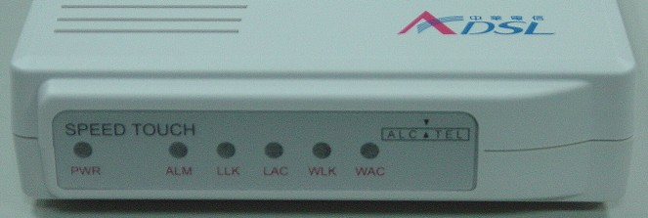

PWR—Power LED (Usually lit yellow constantly)
ALM—Alarm LED (Usually not lit)
LLK－ LAN connection LED
LAC－ Flashes orange when reading from LAN
（Normally lit constant yellow; if not, check internal network settings are correct）
WLK－Wide area network (WAN) connection LED
WAC－ Flashes orange when reading from WAN
(Normally lit constant yellow)

