Part 1 ADSL equipment requirements

First check to make sure you have all the hardware and software required. Since So-net is currently partnered with Chunghwa Telecom, your ADSL line is provided by Chunghwa Telecom. Your ADSL modem and splitter are also provided by Chunghwa Telecom. If you decide to terminate the service, they must be returned to Chunghwa Telecom.

- Personal Computer (PC) – we recommend minimum Pentium 166MHz, 64MB RAM, 20Mb hard drive, 4 speed CD-ROM drive.
- Network adapter (also called Network Interface Card, NIC) – Specification: RJ45 port, Speed: 10/100 Base-T. A network adapter is a vital part of broadband equipment. Whereas a standard “narrowband” modem can only reach 56kbps, with a network adapter you can achieve speeds of 10Mbps. With ADSL you can also enjoy rapid downloading from the Internet. A network adapter is pictured below:
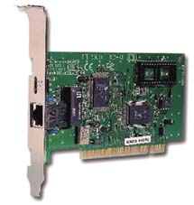
Note 1: In principle any ethernet card with a RJ45 connector will work. There are no special requirements for particular brands or functions.
Note 2: Installation of a network adapter may differ from PC to PC. Either install it yourself or ask a qualified computer technician to help.

- Standard telephone line – you can use your current home phone line or apply for a new line.
- ADSL user name and password (apply to So-net for this).
- PPPoE connection program (Variable IP ADSL need to be installed this program, it can be download from So-net website http://www.so-net.net.tw/service/download/dial.html.)
- ADSL modem - also referred to as an ATU-R; provided by Chunghwa Telecom, it must be returned if service is terminated.
- ADSL splitter- provided by Chunghwa Telecom, it must be returned if service is terminated.

